Arzoo_task1

Assessment1: "html-css-task1
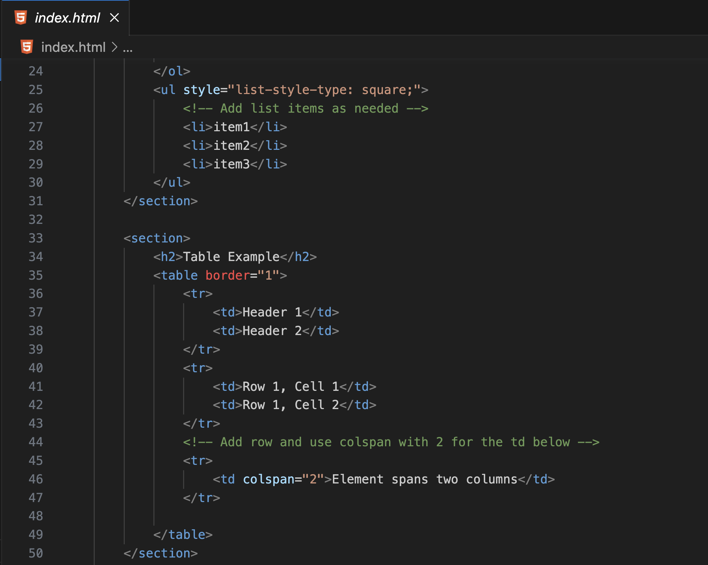

HTML Task1, Task2

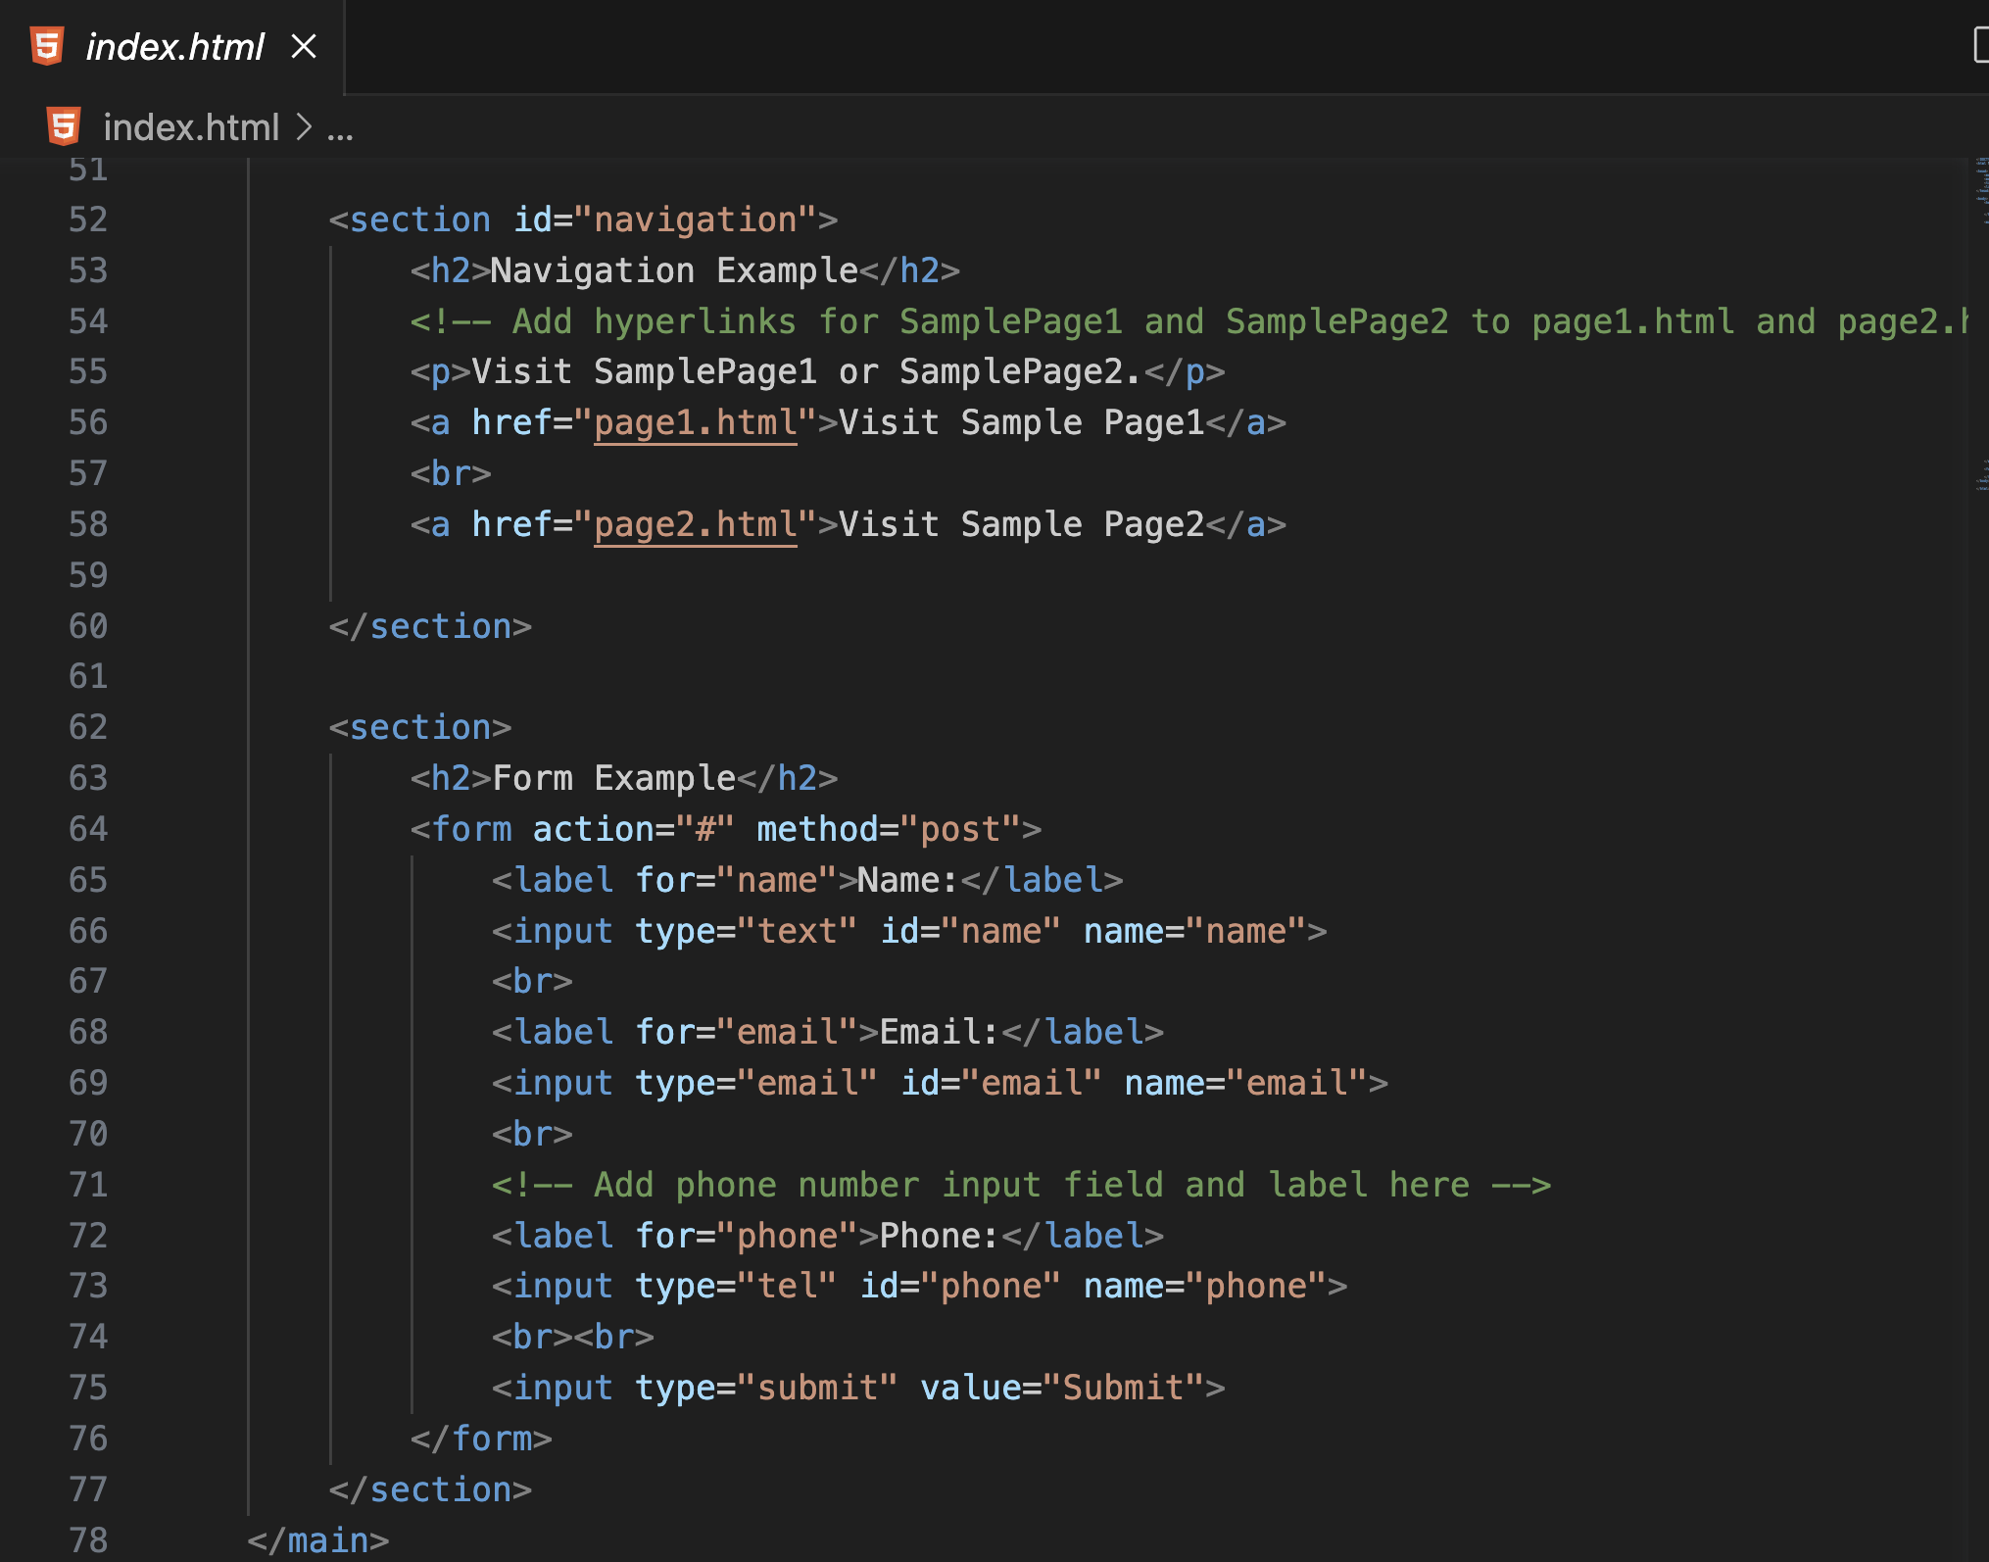

HTML Task3, Task4

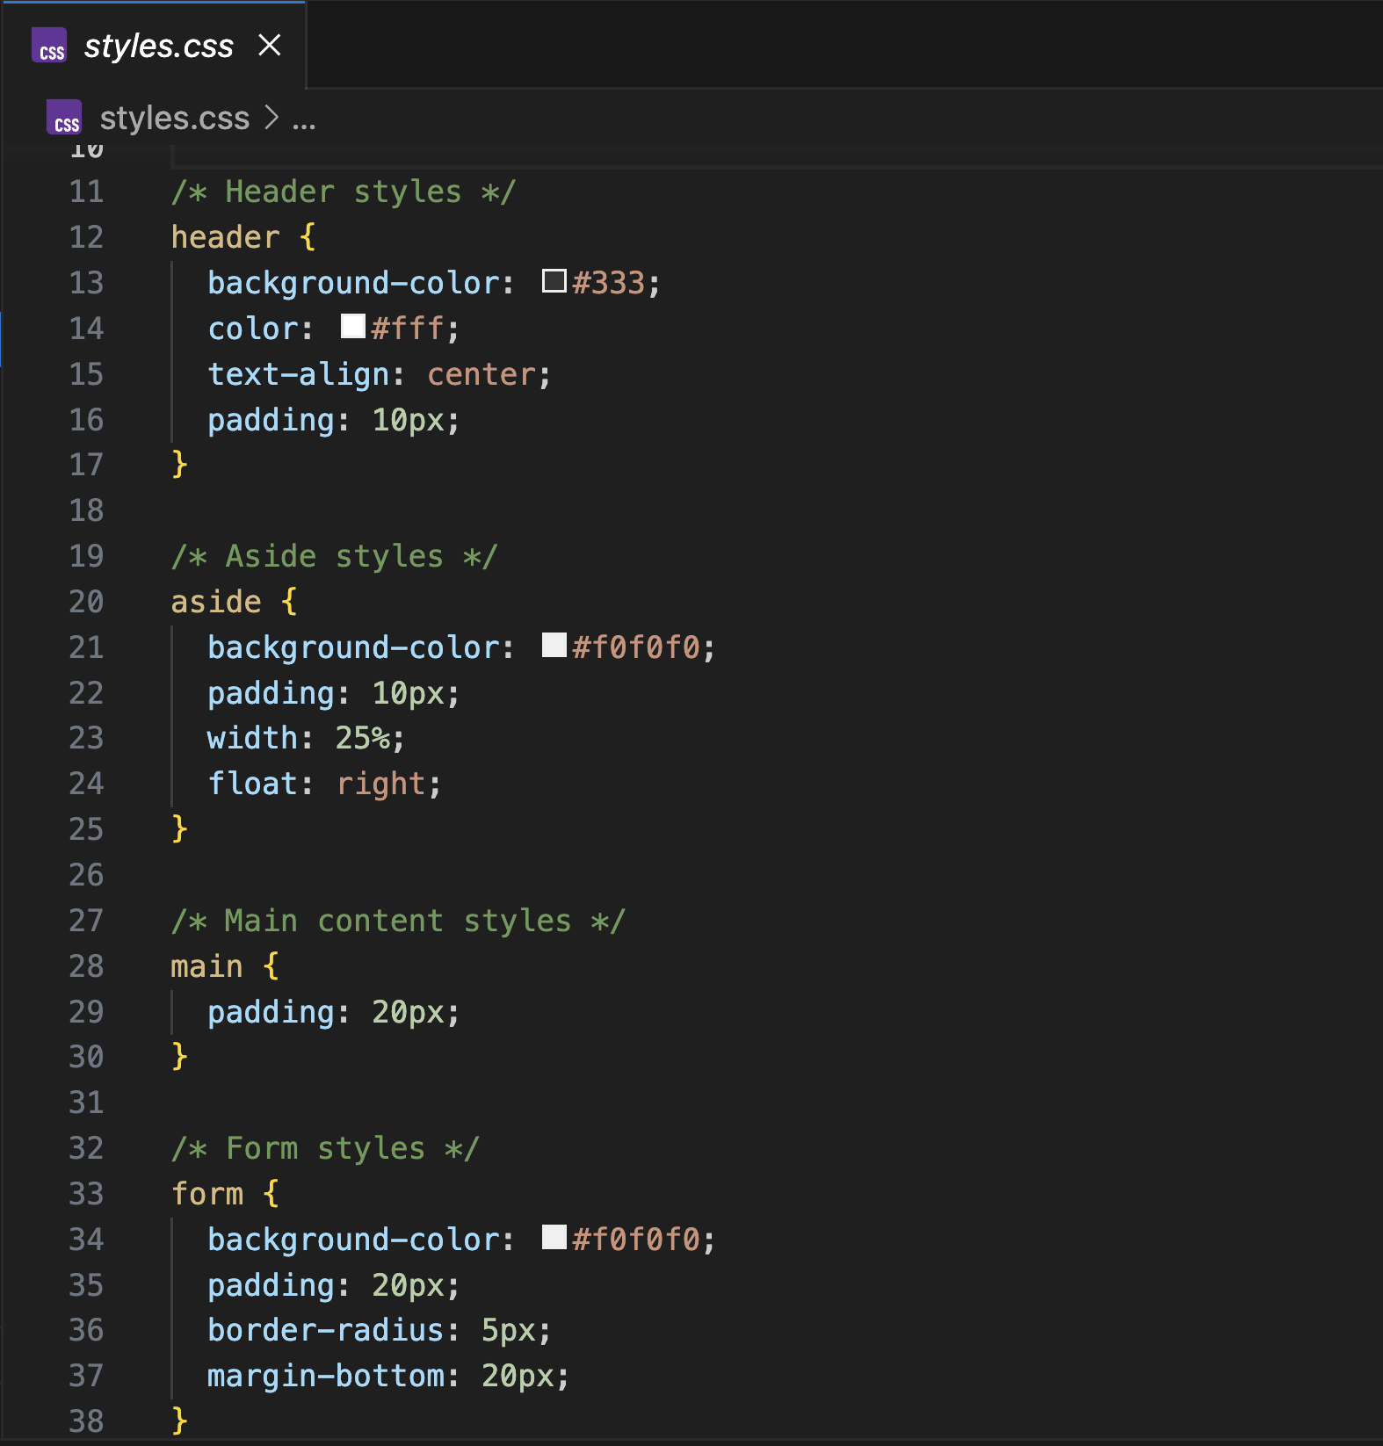

CSS Task1, Task2

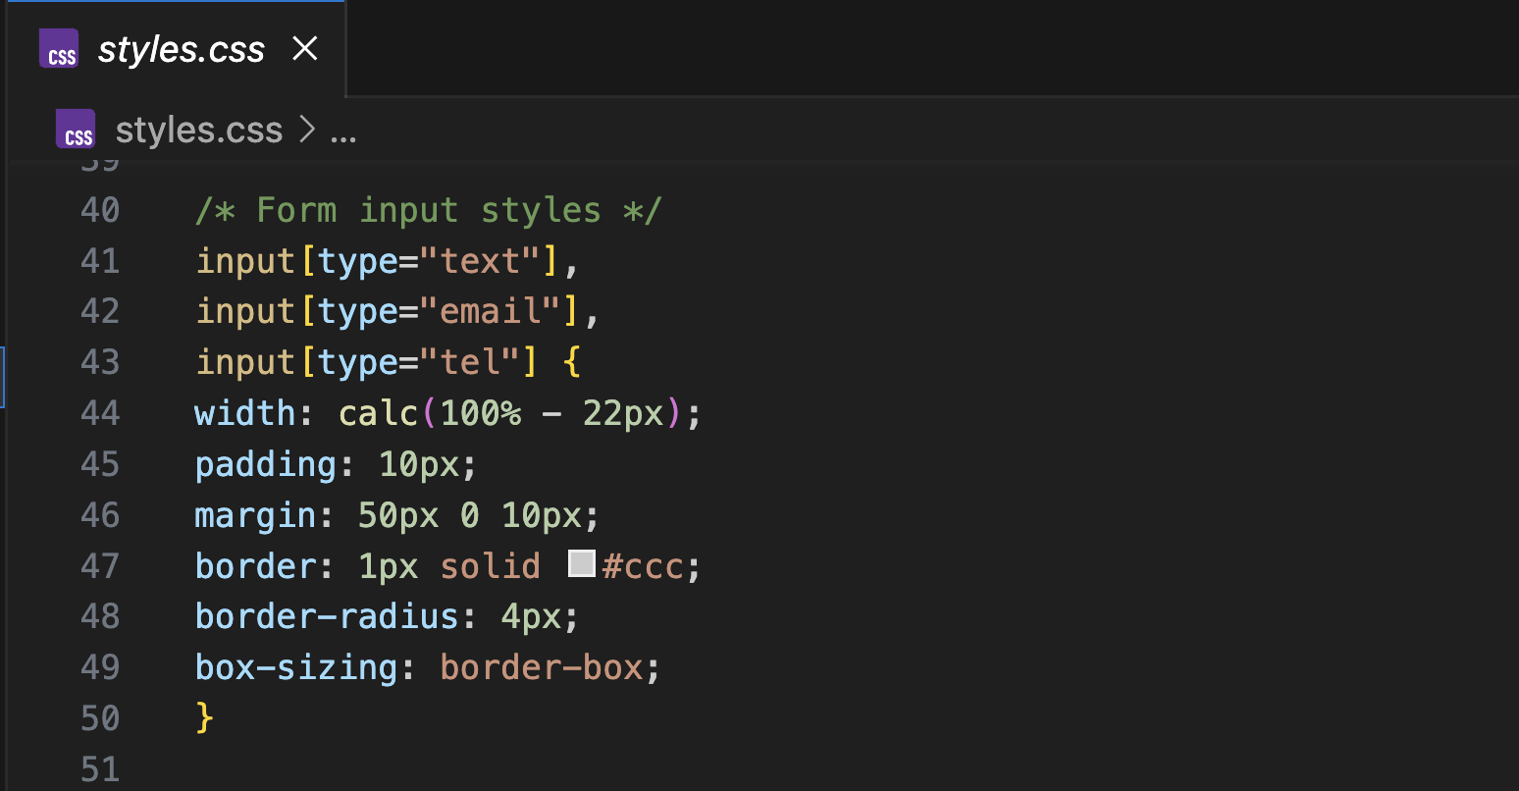

CSS Task3

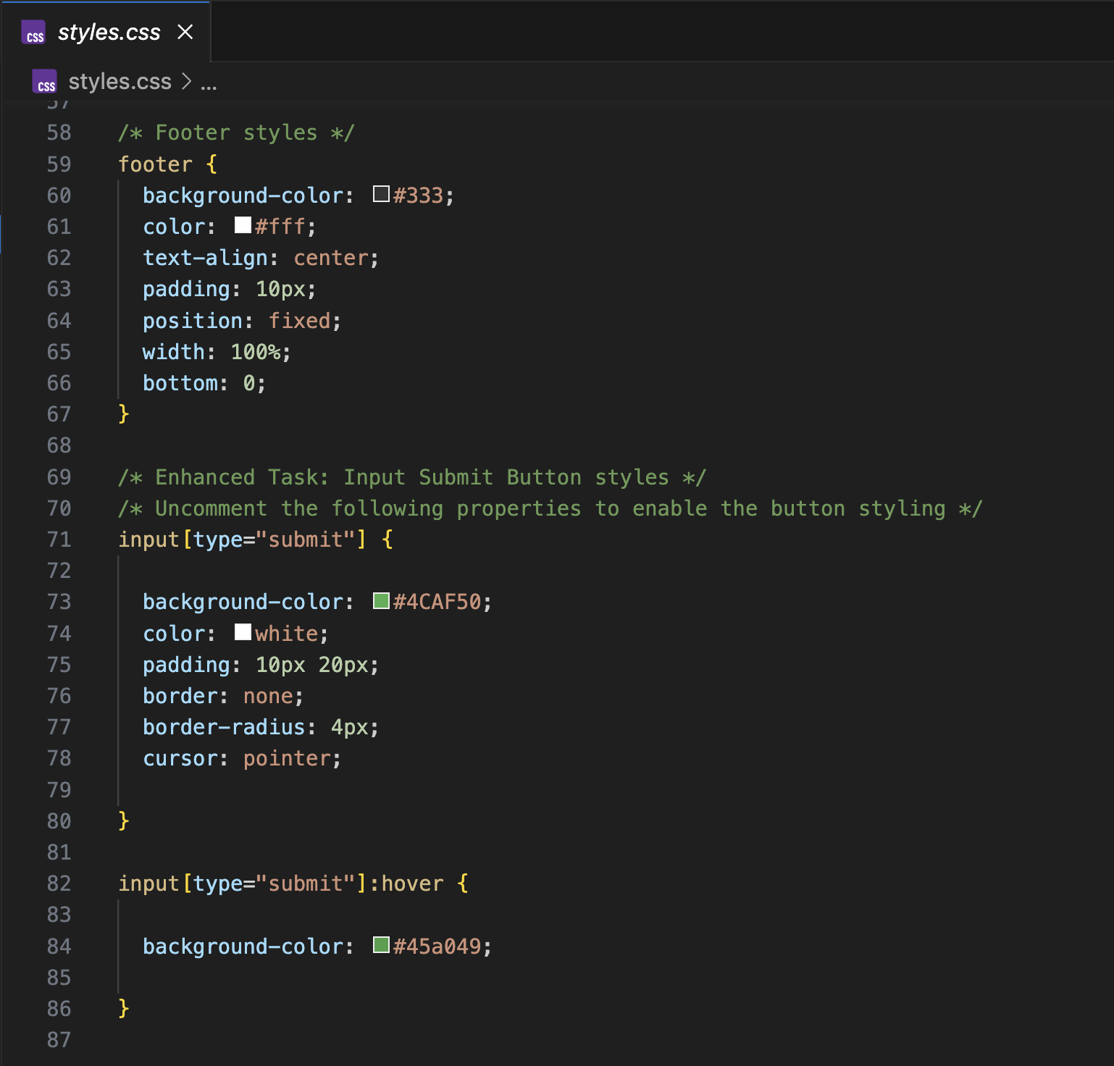

CSS Task4, Enhanced
Task

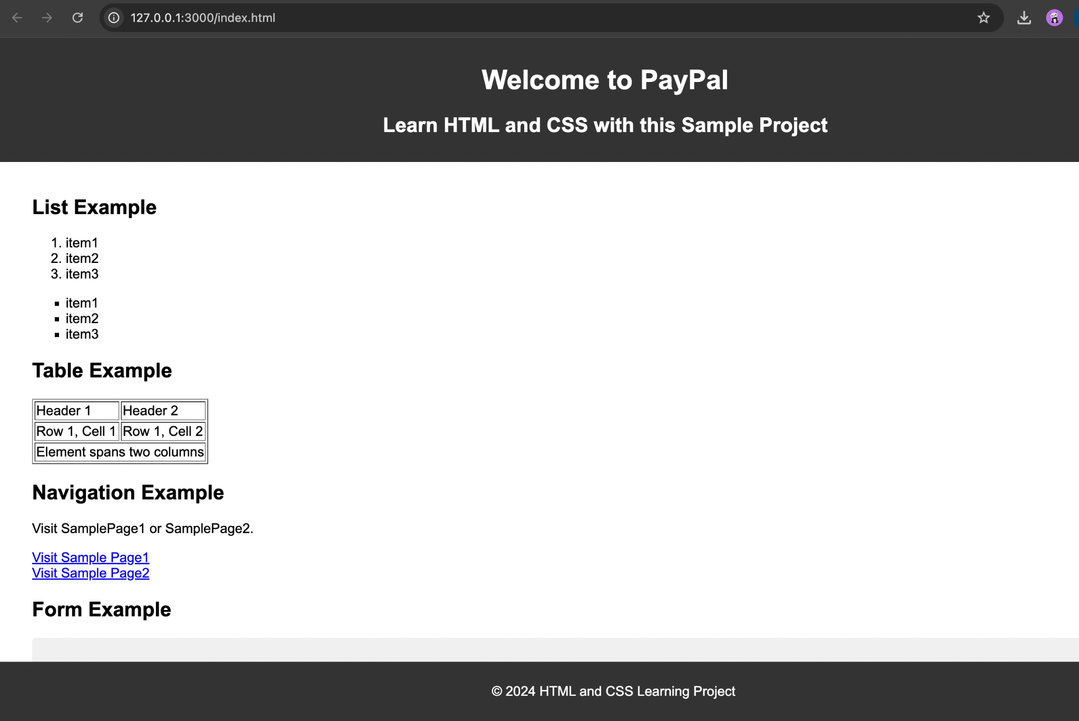

Output

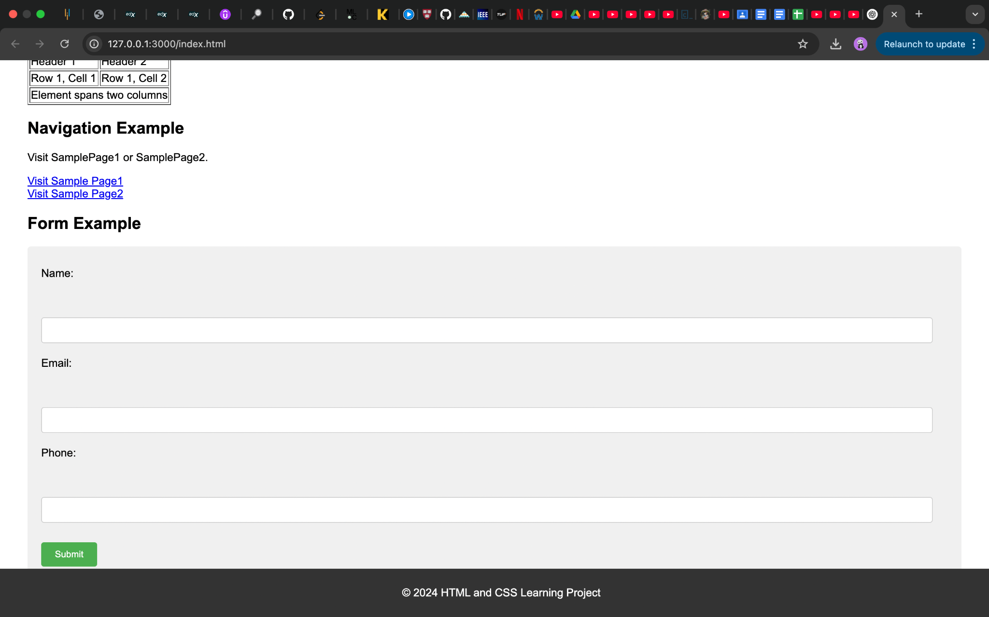
Output

……………………………………………………………………………………………………………

Assessment2: "Git & IntelliJ Assignment

1. What is the use of the git add command?
The git add command adds changes in your working directory to the staging area. It tells Git which changes you want to include in the next commit.

2. Write the command to create a branch “feature-group”.
Command: git branch feature-group (creates a new branch named feature-group from your current branch)

3. What is a pull request? Write the steps involved in creating a pull request.
A pull request (PR) is a way to propose changes from one branch to another, usually for code review before merging.
The steps involved are :
- Push your branch to GitHub
- Go to the repository
- Click "Compare & pull request"
- Add details
- Click "Create pull request"

4. How do you add collaborators?
To add collaborators :
- Go to your GitHub repository
- Click on "Settings"
- Select "Collaborators and teams"
- Add the username or email of the collaborator
Then, GitHub will send them an invitation to contribute.

5. What is the command used to commit our changes in GitHub repo?
Command : git commit -m "Commit message" ( saves your staged changes with a message describing what you did)

6. Create a GitHub account and repository to save all your assignment tasks. Example repository name: rg-assignments
The steps for the same are listed below :
- Go to github.com
- Sign up for an account
- After logging in, click "New" to create a repository named rg-assignments.
You can use this repository to store all your assignment files.

7. Create a branch called feature-java (you can use it later to push all your Java-related tasks to this branch)
Command : git branch feature-java (creates a new branch named feature-java)

8. Install IntelliJ IDE. Create a simple Java project displaying “Hello World!!” and share the screenshot.
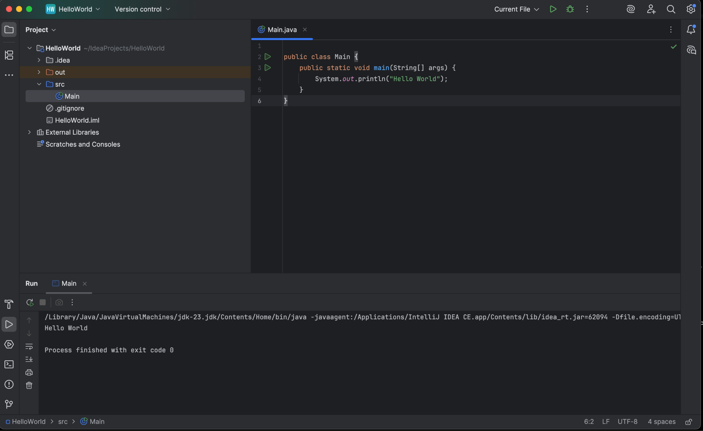

9. In IntelliJ IDE, explore the shortcut keys for the following:

- To run the project: Shift + F10
- To select a line: Home, then Shift + End
- To comment/uncomment a line: Ctrl + / (Windows/Linux) or Cmd + / (Mac)
- To delete a line: Ctrl + Y (Windows/Linux) or Cmd + Backspace (Mac)

